 

**DEV SANSKRITI VISHWAVIDYALAYA**

SESSION 2018-21

**Practical File**

**Of**

**Internet and**

**Web Technologies**

**Submitted To: Submitted By:**

Mrs. Geetanjali Gaidhani Sujeet Kumar

Lecturer BCA (5th Sem.)

**Department of Computer Science,**

DSVV, Haridwar

www.dsvv.ac.in

**INDEX**

**HTML & CSS**

|  |  |  |
| --- | --- | --- |
| **S. No.** | **Task** | **Page No** |
| **1** | Create a student registration web page using HTML form objects. | 6-7 |
| **2** | Create a table having student information using HTML. | 8-9 |
| **3** | Explain following tags: <marquee>,<sup>,<pre>,<hr>,<iframe> with respective output. | 10-14 |
| **4** | Design a customer registration form for online shopping. | 15-16 |
| **5** | Create a simple HTML page having multiple frames. | 17 |
| **6** | Embed video in an HTML page. | 18 |
| **7** | Create a simple HTML page that uses inline CSS. | 19 |
| **8** | Create a simple HTML page that uses document level CSS. | 20-21 |
| **9** | Create an HTML page that uses external CSS. | 22-23 |
| **10** | Create an HTML page that uses all CSS Font properties. | 24-25 |
| **11** | Create an HTML page that uses all CSS Text properties. | 26-27 |
| **12** | Create an HTML page that uses all CSS Background Properties. | 28-29 |
| **13** | Create an HTML page that uses all CSS border properties. | 30 |
| **14** | Create an HTML page that uses all CSS List properties. | 31-32 |
| **15** | Create a CSS3 based zebra stripped table. | 33-34 |
| **16** | Create a four partition layout using CSS. | 35-36 |
| **17** | Create CSS3 based button. | 37 |
| **18** | Create an HTML page that uses all CSS Margin,Padding properties. | 38-39 |

JavaScript

|  |  |  |
| --- | --- | --- |
| **S. No.** | **Task** | **Page No** |
| **1** | Write an external script and link it to the HTML document. | 41 |
| **2** | Write a script using various operators. | 42-43 |
| **3** | Write a script to demonstrate all kind of conditional structures | 44-45 |
| **4** | Write a script to demonstrate all kinds of looping structures | 46-47 |
| **5** | Write a script to show an alert box for any purpose | 48 |
| **6** | Write a script to use prompt and confirm function | 49 |
| **7** | Write a script to demonstrate creation and use of an array | 50 |
| **8** | Write a script that uses a user defined function | 51 |
| **9** | Write a script that uses any of the object of BOM | 52 |
| **10** | Write a script that uses any of the object of DOM | 53 |
| **11** | Write a script to access any of the form object element | 54 |
| **12** | Write a script using all of the events | 55-56 |
| **13** | Write a script to deal with cookies. | 57 |
| **14** | Write a script to detect various aspects of Browser | 58-59 |
| **15** | Write a script that uses Time events. | 60-61 |
| **16** | Create a Webpage based calculator | 62-64 |

**PHP**

|  |  |  |
| --- | --- | --- |
| **S. No.** | **Task** | **Page No.** |
| **1.** | Write a PHP script to get the PHP version and configuration information | **66-67** |
| **2.** | Write a PHP script to display any multi-line string | **68** |
| **3.** | Write a PHP script to place a variable to a title and as hyperlink of the Web page | **69** |
| **4.** | Create a simple HTML form and accept the user name and display the name through PHP echo statement | **70** |
| **5.** | Write a PHP script to get IP address of a client | **71** |
| **6.** | Write a PHP script for Browser detection | **72** |
| **7.** | Write a PHP script to get the current filename | **73** |
| **8.** | Create a PHP script using a for loop to add up all the integers between 0 and 30 and display the total | **74** |
| **9.** | Create a function to calculate the factorial of a number (non-negative integer). The function accept the number as a argument. | **75** |
| **10.** | Write a function to check a number is prime or not | **76** |
| **11.** | Write a function to sort an array | **77** |
| **12.** | Write a PHP function that checks if a string is all lower case | **78** |
| **13.** | Write a PHP function that checks whether a passed string is palindrome or not | **79** |
| **14.** | Write a PHP script to deal with cookies | **80-81** |
| **15.** | Write a PHP script to handle session | **82** |

**MySql**

|  |  |  |
| --- | --- | --- |
| **S . No.** | **Task** | **Page No.** |
| **1.** | Use MySQL console to use database | **84** |
| **2.** | Create a database in MySQL | **85** |
| **3.** | Create a table in selected database | **86** |
| **4.** | Insert new records in MySQL table | **87** |
| **5.** | Retrieve records from the database | **88** |
| **6.** | Update the records in a table | **89** |
| **7.** | Delete a specific record in a table | **90** |
| **8.** | Delete the table from the database | **91** |
| **9.** | Delete the database | **92** |
| **10.** | Write a PHP script to establish a connection to the database and retrieve the data | **93-94** |

**HTML & CSS**

**1. Create a student registration web page using HTML form objects.**

**Code:**

<!DOCTYPE html>

<html>

<head>

<title>Form Implementation</title>

</head>

<body>

<form>

First Name:- <input type="text" name="Firstname"><br>

Last Name :- <input type="text" name="Lastnamw"><br>

Date of Birth:- <input type ="date" name="date"><br>

email Id:-<input type="email" required name = "email"><br>

password:- <input type = "password" minlenght="6" name = "password"><br>

gender:- <br>

Male:- <input type= "radio" name="gender" value="male"><br>

Female:- <input type="radio" name="gender" value="female"><br>

Qualification:- <br>

<input type ="checkbox" name="Graduate">Graduate<br>

<input type ="checkbox" name ="Post graduate">post graduate<br>

<input type ="checkbox" name ="Diploma">Diploma<br>

Hobby:-

<select>

<option value ="Hockey"> hockey</option>

<option value ="Cricket">cricket</option>

<option value ="Football">football</option>

</select><br>

<input type ="Submit" value ="Register">

<input type ="reset" value ="Reset">

</form>

</body>

</html>

**Output:**

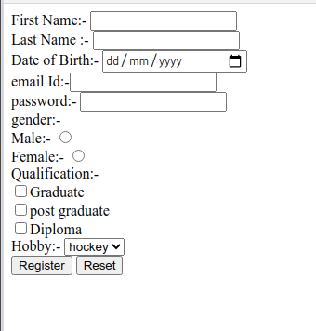

**2. Create a table having student information using HTML.**

**Code:**

<!DOCTYPE html>

<html>

<head>

<title>Student Information Table</title>

</head>

<body>

<h2>Student Information Table</h2>

<table border ="1">

<tr>

<th>Roll No.</th>

<th>Name</th>

<th>Course</th>

<th>Gender</th>

<th>Mobile</th>

<th>Address</th>

</tr>

<tr>

<td>136899</td>

<td>Aakas </td>

<td>B.Sc</td>

<td>Male</td>

<td>2579348</td>

<td>xxxxxx</td>

</tr>

<tr>

<td>136898</td>

<td>Roshan</td>

<td>BCA</td>

<td>Male</td>

<td>563289</td>

<td>xxxxxx</td>

</tr>

<tr>

<td>136897</td>

<td>Arpita</td>

<td> MCA</td>

<td>Female</td>

<td>843833</td>

<td>xxxxx</td>

</tr>

<tr>

<td>136896</td>

<td> Shyam</td>

<td>M.Sc</td>

<td>Male</td>

<td>262739</td>

<td>yyyyyy</td>

</tr>

<tr>

<td> 136895</td>

<td>Anjali</td>

<td>B.Sc</td>

<td>Female</td>

<td>528382</td>

<td>kkkkkk</td>

</table>

</tr>

</body>

</html>

**Output:**

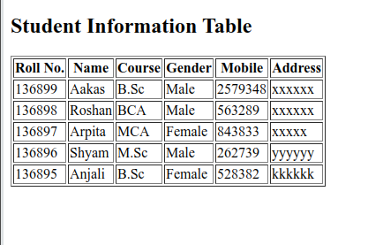

**3. Explain following tags <marquee>,<sup>,<pre>,<hr>,<iframe> with respective output.**

**<Marquee>**

The **Marquee HTML** tag is a non-standard HTML element which is used to scroll a image or text horizontally or vertically.

In simple words, you can say that it scrolls the image or text up, down, left or right automatically.

Marquee tag was first introduced in early versions of Microsoft's Internet Explorer. It is compared with Netscape's blink element.

**Marquee HTML Example:**

<marquee>This is an example of html marquee </marquee>

|  |  |
| --- | --- |
| **Attribute** | **Description** |
| behavior - | It facilitates user to set the behavior of the marquee to one of the three different types: scroll, slide and alternate. |
| direction | defines direction for scrolling content. It may be left, right, up and down. |
| width | defines width of marquee in pixels or %. |
| height | defines height of marquee in pixels or %. |
| hspace | defines horizontal space in pixels around the marquee. |
| vspace | defines vertical space in pixels around the marquee. |
| scrolldelay | defines scroll delay in seconds. |
| scrollamount | defines scroll amount in number. |
| loop | defines loop for marquee content in number. |
| bgcolor | defines background color. It is now *deprecated*. |

**2. <sup> tag:**

HTML <sup> tag is termed as a superscript tag which is used to define superscript text. The text within <sup> tag appears with an upper baseline and renders with smaller font size than surrounding text.

The <sup> tag is useful for defining Mathematical formulas and footnotes.

**Syntax**

<sup>......</sup>

**3. HTML <pre> tag:**

The **HTML <pre> tag** is used to specify pre-formatted texts. Texts within <pre>.......</pre> tag is displayed in a fixed-width font. Usually it is displayed in Courier font. It maintains both space and line break.

It is widely used to display language examples e.g. Java, C#, C, C++ etc because it displays the code as it is typed.

**Example:**

<pre>

This is a formatted text

by using the HTML pre tag. It maintains

    both space and line break.

</pre>

**4.** **HTML <hr> tag:**

HTML <hr> tag is used to specify a paragraph-level thematic break in HTML document. It is used when you abruptly change your topic in your HTML document. It draw a horizontal line between them. It is also called a Horizontal Rule in HTML.

**Example:**

<h2>HTML</h2>

<p>HTML is a language for describing web pages. </p>

<hr/>

<h2>HR Tag </h2>

<p> HR tag is used to draw a horizontal line within the texts to sepate content. <p>

**5. HTML iframes:**

HTML Iframe is used to display a nested webpage (a webpage within a webpage). The HTML <iframe> tag defines an inline frame; hence it is also called as an Inline frame.

An HTML iframe embeds another document within the current HTML document in the rectangular region.

The webpage content and iframe contents can interact with each other using JavaScript.

**Example:**

<iframe src="https://.....com title="XYZ"></iframe>

|  |  |  |
| --- | --- | --- |
| **Attribute** | **Value** | **Description** |
| allow |  | Specifies a feature policy for the <iframe> |
| allowfullscreen | true false | Set to true if the <iframe> can activate fullscreen mode by calling the requestFullscreen() method |
| allowpaymentrequest | true false | Set to true if a cross-origin <iframe> should be allowed to invoke the Payment Request API |
| height | *pixels* | Specifies the height of an <iframe>. Default height is 150 pixels |
| name | *text* | Specifies the name of an <iframe> |
| referrerpolicy | no-referrer no-referrer-when-downgrade origin origin-when-cross-origin same-origin strict-origin strict-origin-when-cross-origin unsafe-url | Specifies how much/which referrer information that will be sent when processing the iframe attributes |
| sandbox | allow-forms allow-pointer-lock allow-popups allow-same-origin allow-scripts allow-top-navigation | Enables an extra set of restrictions for the content in an <iframe> |
| src | *URL* | Specifies the address of the document to embed in the <iframe> |
| srcdoc | *HTML_code* | Specifies the HTML content of the page to show in the <iframe> |
| width | *pixels* | Specifies the width of an <iframe>. Default width is 300 pixels |

**Code:**

<!DOCTYPE html>

<html>

<head>

<title>A webpage for <marquee>,<sup>,<pre>,<hr> and <iframe> tags</title>

</head>

<body>

<h1> <marquee>This is an example of marquee tag. </marquee>

</h1>

<hr>

<h2>

<p>

We use "sup" tag for Superscripts.

5<sup>2</sup> + 3<sup>3</sup> = 52

</p>

</h2>

<hr>

<h3>

<pre> This is

an example

of preformatted tag.(pre tag)

</pre>

</h3>

<hr>

<h3>"hr" tag is used for <b> horizontal link break</b> just like above and below.

</h3>

<hr>

<h3>

This is an Example of "iframe" tag.</h3>

<iframe src="https://pranav40.github.io/" width= "80%" hight="300%" ></iframe>

<hr>

</body>

</html>

**Output:**

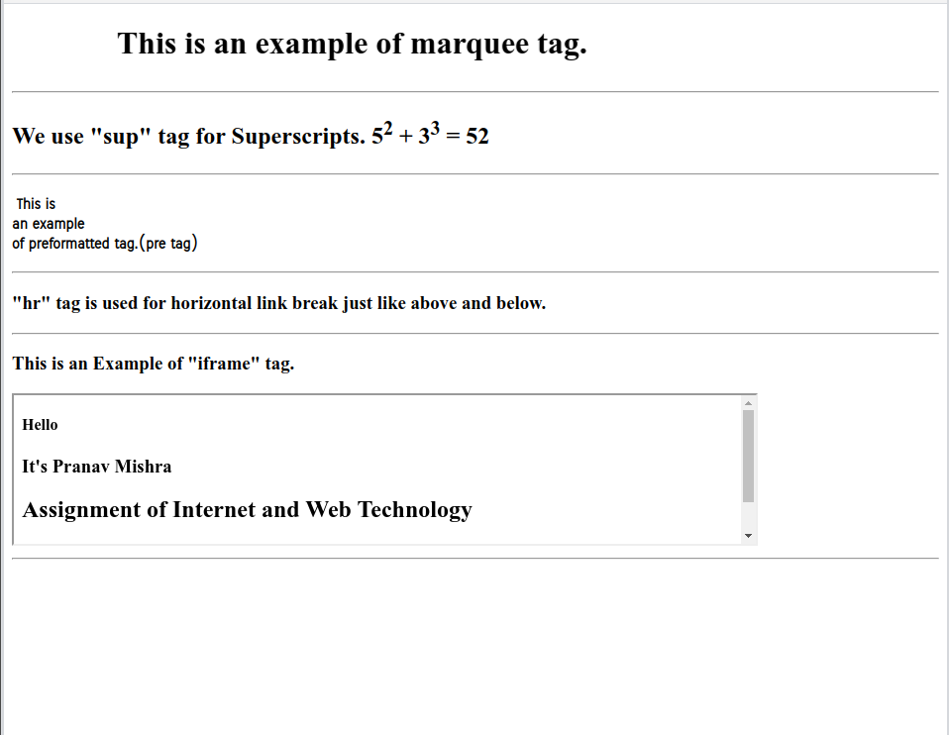

**4. Design a customer registration form for online shopping.**

**Code:**

<!DOCTYPE html>

<html>

<head>

<title>Costomer Registration Form for Online Shopping</title>

</head>

<body bgcolor="Yellow" align= center>

<h1>Create account</h1><hr>

<p>Please fill in this form to create an account.</p>

<form>

Your name:- <input type="text" name="Firstname" placeholder="Your name"><br> <br>

Shipping Address:- <input type="cols=70" "row=3" placeholder="Address"><br><br>

Email Id:-<input type="email" required name = "email" placeholder="Email"><br> <br>

Password:- <input type = "password" name = "password" placeholder="Password" minlenght="6" ><br> <br>

Confirm Password:-

<input type = "password" name="repassword" placeholder="Confirm Password" minlenght="6"><br><br>

<input type="submit" value="create account"><hr>

</form>

</body>

</html>

**Output:**

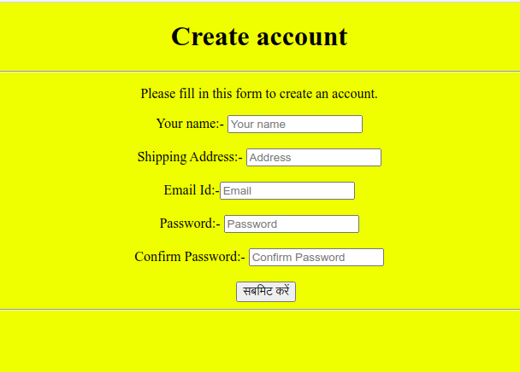

**Task 5:-**

<!DOCTYPE html>

<html>

<head>

<title>A a simple HTML page having multiple frames.</title>

</head>

<frameset cols="*,*">

<frame src="https://knowledgewit.wordpress.com/author/pranavdsvv/">

<frameset rows="*,*">

<frame src="https://pranav40.github.io">

<frame src="https://bca1821.github.io/UTSAV">

</frameset>

</frameset>

</html>

**Output:**



**Task 6:-**

<!DOCTYPE html>

<html>

<head>

<title>

Video

</title>

</head>

<body>

<video height="480" width="540" controls>

<source src="video1.mp4" type="video/mp4">

</video>

</body>

</html>

**Output:**

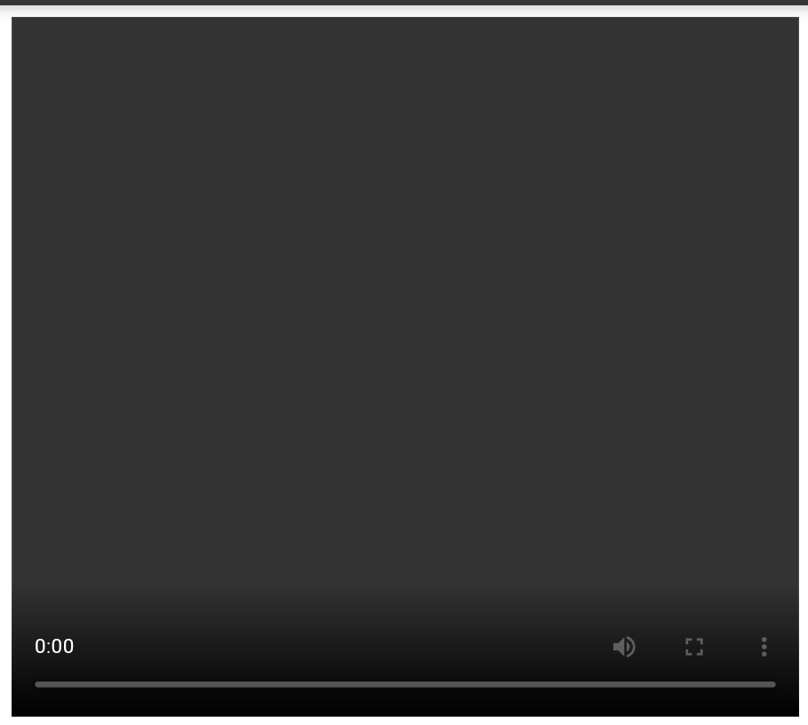

**Task 7:-**

<!DOCTYPE html>

<html>

<head>

<title> Inline CSS</title>

</head>

<body bgcolor ="black">

<h1 style="color:rgb(54,120,179);"> Welcome........</h1>

<p style="color:rgb(12,220,190); font-size:30px;">This page is created by using Inline CSS.</p>

</body>

</html>

**Output:**



**Task 8:-**

<!DOCTYPE html>

<html>

<head>

<title> Document (Internal level) CSS</title>

<style>

body

{ background-image: url( https://i.stack.imgur.com/vhoa0.jpg );

}

.first{

color: black;

font-size: 45px;

margin: 70px;

}

.second

{

color: black;

font-size: 25px;

margin: 90px;

}

</style>

</head>

<body>

<div class="first">

Welcome.....

<hr>

</div>

<div class="second">

<p> This page is created by using Internal CSS.</p>

</div>

</body>

</html>

**Output:**



**Task 9:-**

<!DOCTYPE html>

<html>

<head>

<title>External level CSS</title>

<link rel="stylesheet" type="text/css" href="Externalcss5.css">

</head>

<body>

<div class="first">

Welcome.....

<hr>

</div>

<div class="second">

<p> This page is created by using Internal CSS.</p>

</div>

</body>

</html>

CSS Program:-

body

{ background-image: url( https://i.stack.imgur.com/vhoa0.jpg );

}

.first

{

color: black;

font-size: 45px;

margin: 70px;

}

.second

{

color: black;

font-size: 25px;

margin: 90px;

}

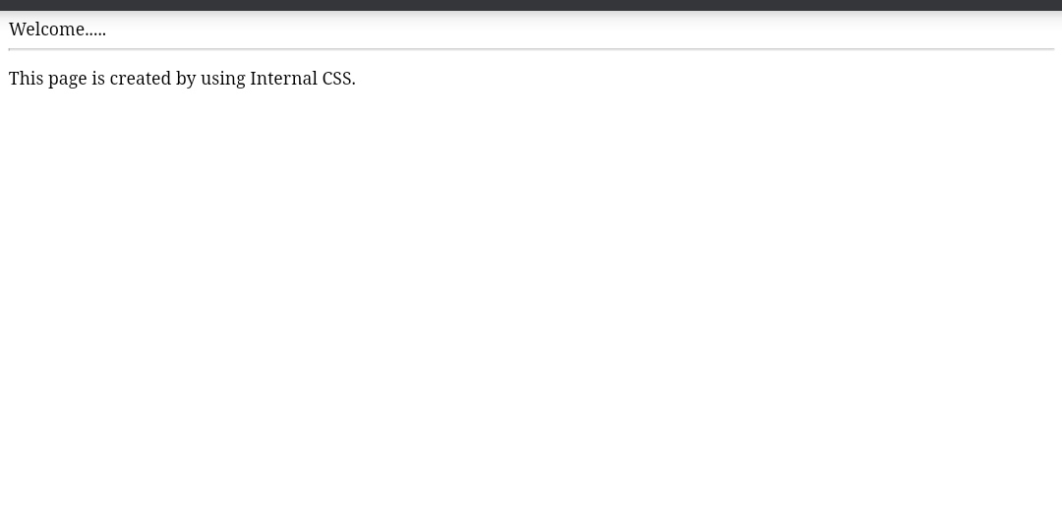**Output:**

**Task 10:-**

<!DOCTYPE html>

<html>

<head>

<title> All CSS Font Properties</title>

<style>

body

{ background-image: url( https://i.stack.imgur.com/vhoa0.jpg );

}

.properties{

color: black;

font-size: 80px;

margin: 100px 70px;

font-variant: small-caps;

font-weight: lighter;

line-hight:250%;

}

</style>

</head>

<body>

<div class="properties">

<centre><hr><p>Successful and unsuccessful people do not vary greatly in their abilities. </p><hr></center>

</div>

</body>

</html>

**Output:**



**Task 11:-**

<!DOCTYPE html>

<html>

<head>

<title> Text Properties</title>

<style>

body

{ background-image: url( https://i.stack.imgur.com/vhoa0.jpg ); color:white;

}

h1{

text-algin: center;

text-decoration: underline;

text-transform: capitalize;

letter-spacing:3px;

line-hieght:100px;

text-shadow:2px 3px 4px white;

}

h2{

float:leaft;

margin-leaft: 50px;

word-spacing: 40px;

text-shadow: 3px 3px 3px teal;

}

</style>

</head>

<body>

<h1>"There are no shortcuts to any place worth going."</h1><hr>

<h2>Education is the most powerful weapon you can use to change the world.<hr></h2>

</body>

</html>

**Output:**

**Task 12:-**

<!DOCTYPE html>

<html>

<head>

<title> CSS Background Properties</title>

<style>

body

{ background-image: url(https://www.google.com/search?q=background+image+web+technology&tbm=isch&ved=2ahUKEwjo1u_3zvfrAhWikuYKHcrTCWIQ2-cCegQIABAC&oq=background+image+web+technology&gs_lcp=ChJtb2JpbGUtZ3dzLXdpei1pbWcQAzIGCAAQCBAeMgUIABDNAjIFCAAQzQI6BAgAEEM6AggAOgQIIxAnOgUIABCxAzoECCEQClCXF1jRfWCPiAFoAHAAeACAAdACiAGpL5IBBjItMTguNJgBAKABAcABAQ&sclient=mobile-gws-wiz-img&ei=MTtnX6j6LaKlmgfKp6eQBg&bih=766&biw=393&client=ms-android-xiaomi-rev1&prmd=ivsn#imgrc=u6-GuVO-RrIpGM);

background-attachment: fixed;

background-repeat: no-repeat;

background-position: centre;

}

<div>

{

color: red;

font-size: 30px;

text-align: center;

margin-top: 90px;

}

</div>

</style>

</head>

<body>

<div>

CSS Background Properties...

</div>

</body>

</html>

**Output:**



**Task 13:-**

<!DOCTYPE html>

<html>

<head>

<title> CSS Border Properties</title>

<style>

div

{

border: 5px double white;

border-top-style: dotted;

height: 200px;

width: 600px;

padding: 40px;

border-bottom-color: teal;

font-size: 40px;

}

</style>

</head>

<body bgcolor="skyblue">

<div>

<p> Border properties are used in this paragraph.</p>

</div>

</body>

</html>

**Output:**

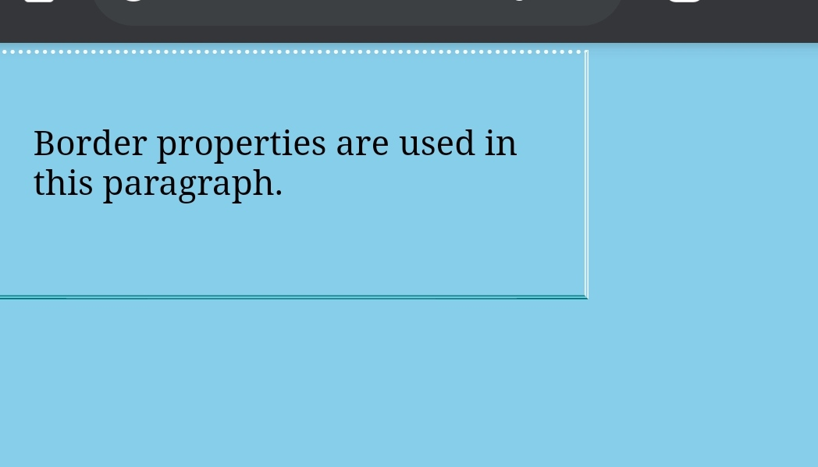

**Task 14:-**

<!DOCTYPE html>

<html>

<head>

<title> CSS Border Properties</title>

<style>

ul

{

list-style-type: square;

background: rgb(90 170 220);

}

ul li

{

background: rgb(166 221 208);

padding: 10px;

}

ol

{

list-style-type: lower-greek;

background: rgb(225 235 233);

}

ol li

{

background: rgb(176 221 166);

padding: 10px;

marging: 5px;

}

</style>

</head>

<body>

<div>

<ul>

<li>Unordered</li>

<li>List</li>

</ul>

<ol>

<li>Ordered</li>

<li>List</li>

</ol>

</div>

</body>

</html>

**Output:**

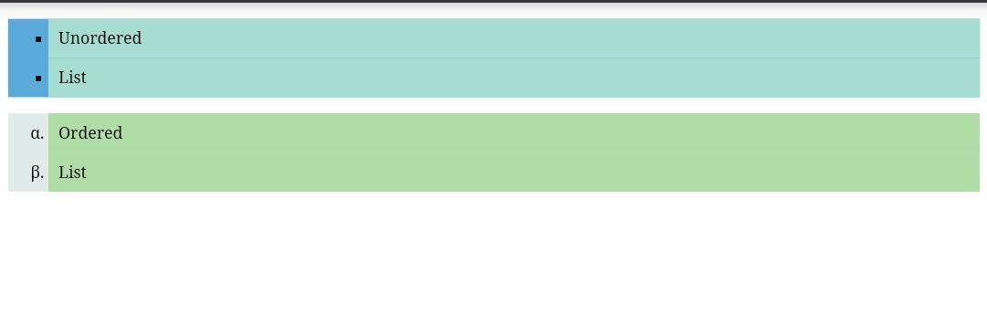

**Task 15:-**

<!DOCTYPE html>

<html>

<head>

<style>

tr:nth-child(even) {

background-color: white;

}

tr:nth-child(odd) {

background-color: black;

color: white;

}

th{

font-size: 20px;

}

</style>

<title>Zebra Striped Table</title>

</head>

<body>

<h4>This table contains information about

students.</h4>

<table border ="1">

<tr>

<th>Roll No.</th>

<th>Name</th>

<th>Course</th>

<th>Gender</th>

<th>Mobile</th>

<th>Address</th>

</tr>

<tr>

<td>136899</td>

<td>Aakas </td>

<td>B.Sc</td>

<td>Male</td>

<td>2579348</td>

<td>xxxxxx</td>

</tr>

<tr>

<td>136898</td>

<td>Roshan</td>

<td>BCA</td>

<td>Male</td>

<td>563289</td>

<td>xxxxxx</td>

</tr>

<tr>

<td>136897</td>

<td>Arpita</td>

<td> MCA</td>

<td>Female</td>

<td>843833</td>

<td>xxxxx</td>

</tr>

<tr>

<td>136896</td>

<td> Shyam</td>

<td>M.Sc</td>

<td>Male</td>

<td>262739</td>

<td>yyyyyy</td>

</tr>

<tr>

<td> 136895</td>

<td>Anjali</td>

<td>B.Sc</td>

<td>Female</td>

<td>528382</td>

<td>kkkkkk</td>

</table>

</body>

</html>

**Output:**

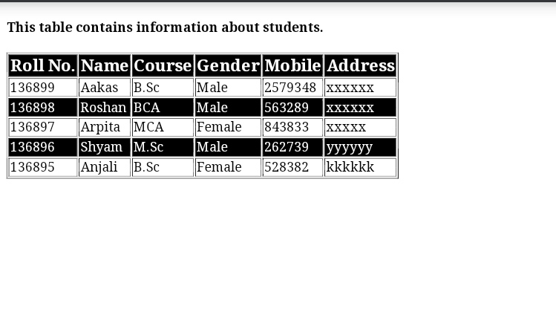

**Task 16:-**

<!DOCTYPE html>

<html>

<head>

<title>4 Partition Layout</title>

<style>

.row{

display: flex;

}

.column{

flex: 50%;

height: 500px;

}

</style>

</head>

<body>

<div class="row">

<div class="column" style="background-color:

aquamarine;">

<p> THE BEST WAY TO CHANGE PEOPLE IS

NOT BY RIDICULE BUT BY SHOWING THEM A NEW WAY OF THINKING AND GIVING THEM THE OPPORTUNITY TO CHANGE

</p>

</div>

<div class="column" style="background-color:

bisque;">

<p> JEALOUSY EATS AWAY AT A PERSON IN THE SAME WAY AS A MOTH EATS AWAY AT APIECE OF CLO </p>

</div>

</div>

<div class="row">

<div class="column" style="background-color:

thistle;">

<p> REALISE YOUR INDIVIDUAL SELF WORTH ANDBELIEVE THAT YOU ARE A UNIQUE ANDSIGNIFICANT PERSON IN THE WORLD.

</p>

</div>

<div class="column" style="background-color: steelblue;">

<p> WATCH YOUR THOUGHTS FOR THEY BECOMEWORDS,WATCH YOUR WORDS ,FOR THEY BECOMEACTIONS,WATCH YOUR ACTIONS FOR THEY BECOME YOURHABITS,WATCH YOUR HABITS FOR THEY BECOMECHARACTER,WATCH YOUR CHARACTER FOR IT BECOMES YOURDESTINY. </p></div>

</div>

</body>

</html>

**Output:**

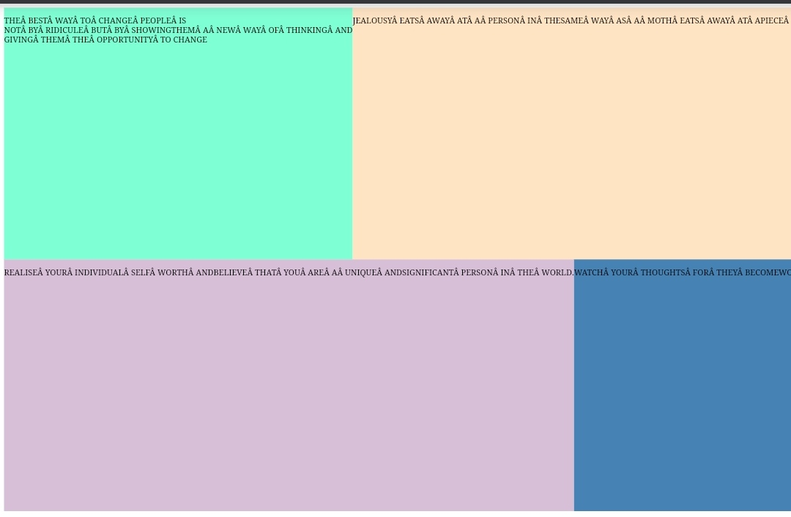

**Task 17:-**

<!DOCTYPE html>

<html>

<head>

<title>

Button

</title>

<style>

.btn{

background-color: blue;

color: white;

padding: 15px;

text-align: center;

font-size: 24px;

border-radius: 20%;

border: 2px solid red;

width: 200px;

}

.btn:hover{

background-color: red;

color: white;

}

.btn:active{

background-color: red;

transform: translateY(4px);

}

</style>

</head>

<body>

<button>simple button</button>

<button class="btn">CSS Button</button>

</body>

</html>

**Output:**

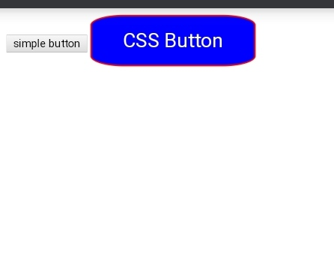

**Task 18:-**

<!DOCTYPE html>

<html>

<head>

<title>CSS Margin and Padding Properties</title>

<style>

h1{

border: 2px solid red;

padding-top: 50px;

padding-right: 30px;

padding-bottom: 50px;

padding-left: 80px;

margin: auto;

}

.a{

border: 1px solid green;

padding: 25px 50px 75px 100px;

margin: 25px 50px 75px 100px;

}

.b{

border: 1px solid blue;

padding: 25px 50px;

margin-top: 100px;

margin-bottom: 100px;

margin-right: 150px;

margin-left: 80px;

}

</style>

</head>

<body>

<h1>An HTML page that uses all CSS Margin and

Padding properties.</h1>

<p class="a">This is first paragraph</p>

<p class="b">This is second paragraph</p>

<p>This is third paragraph (without any CSS)</p>

</body>

</html>

**Output:**

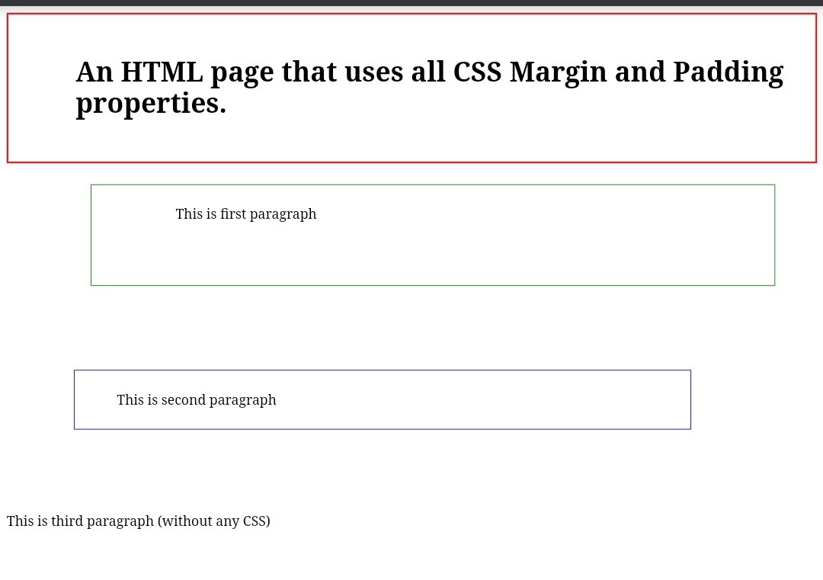

**JavaScript**

**Task 1**

**Write an external script and link it to the HTML document.**

**HTML:**

<!DOCTYPE html>

<html>

<head>

<title>External Script</title>

<script src="js/1. extscript.js" type="text/javascript"></script>

</head>

<body>

<h2>

This is an example of external javascript

</h2>

<h3><script>hello()</script></h3>

</body>

</html>

**JavaScript**

function hello(){

document.writeln("Hello World!\nJavascript speaking.");

}

**Output:**

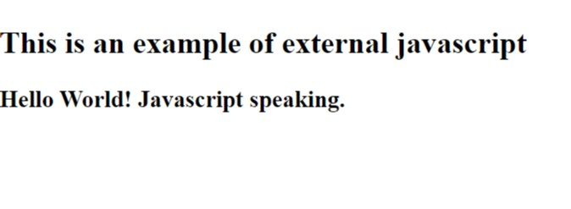

**Task 2**

**Write a script using various operators**

**HTML**

<!DOCTYPE html>

<html>

<head>

<title>Use of operators</title>

<script src="js/2. operators.js" type="text/javascript"></script>

</head>

<body>

<h1>Use of various operators</h1>

<h3><script>

c = add(20,30)

document.write("Addition: ",c)

</script> </h3>

<h3><script>

c = sub(20,30)

document.write("Subtraction: ",c)

</script> </h3>

<h3><script>

c = mul(20,30)

document.write("Multiplication: ",c)

</script> </h3>

<h3><script>

c = div(20,30)

document.write("Division: ",c)

</script> </h3>

<h3><script>

c = mod(20,30)

document.write("Remainder: ",c)

</script> </h3>

</body>

</html>

**JavaScript**

function add(a, b){

return a+b

}

function sub(a, b){

return a-b

}

function mul(a, b){

return a*b

}

function div(a, b){

return a/b

}

function mod(a, b){

return a%b

}

**Output:**

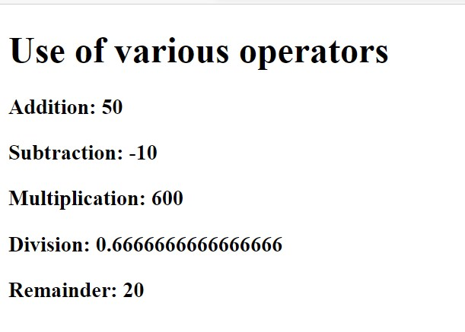

**Task 3**

**Write a script to demonstrate all kind of conditional structures**

**HTML**

<!DOCTYPE html>

<html>

<head>

<title>Conditional statements</title>

<script src="js/3. conditional.js" type="text/javascript"></script>

</head>

<body>

<h2>

conditional structures

</h2>

<h3><script>

ifelse(1)

ifelse(3)

ifelse(4)

ifelse(5)

ifelse(15)

ifelse(-3)

swtch(1)

swtch(3)

swtch(10)

</script></h3>

</body>

</html>

**JavaScript**

function ifelse(i){

if(i<0)

{

document.writeln("Negative <br>")

}

else

{

if(i%3==0 && i%5==0)

{

document.writeln("fizzbuzz <br>")

}

else if (i%3 == 0)

{

document.writeln("fizz <br>")

}

else if (i%5 == 0)

{

document.writeln("buzz <br>")

}

else

{

document.writeln(i, "<br>")

}

}

}

function swtch(n){

switch(n)

{

case 1: document.write("one <br>")

break

case 2: document.write("twp <br>")

break

case 3: document.write("three <br>")

break

case 4: document.write("four <br>")

break

default: document.write(n, "<br>")

}

}

**Output:**

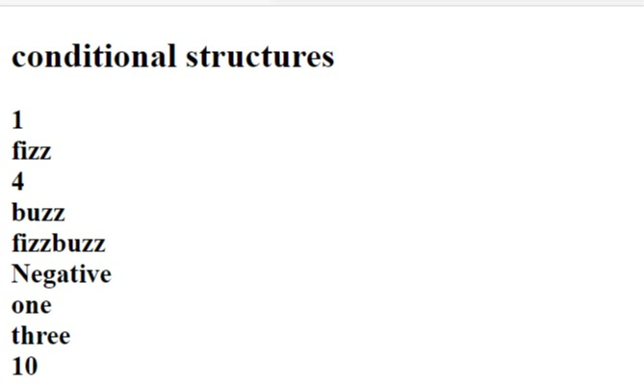

**Task – 4**

**Write a script to demonstrate all kinds of looping structures**

**HTML**

<!DOCTYPE html>

<html>

<head>

<title>Loops</title>

<script src="js/4. loop.js" type="text/javascript"></script>

</head>

<body>

<h2>

This is an example of looping structures

</h2>

<h3>Table of 4:</h3>

<script>table(4)</script>

<h3>Table of 5:</h3>

<script>table1(5)</script>

<h3>Table of 6:</h3>

<script>table1(6)</script>

</body>

</html>

**JavaScript**

function table(n){

var i = 1

for(i=1; i<=10; i++)

{

document.write(n*i, "<br>")

}

}

function table1(n){

var i = 1

while(i!=11)

{

document.write(n*i, "<br>")

i++

}

}

function table2(n){

var i = 1

do

{

document.write(n*i, "<br>")

i++

}while(i!=11)

}

**Output:**

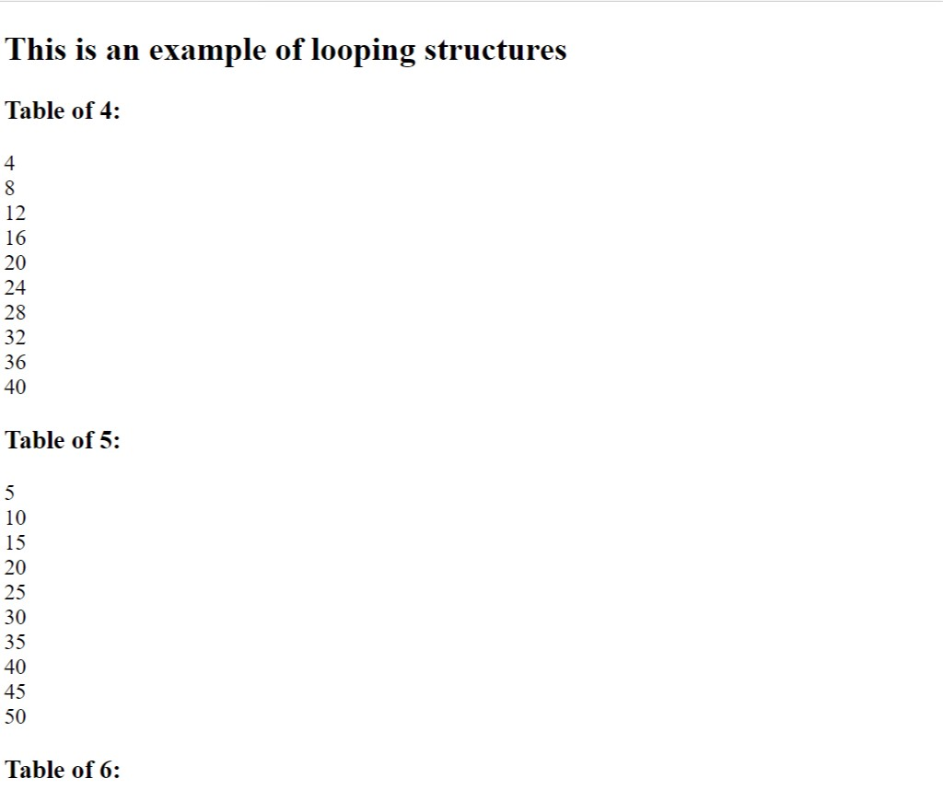

**Task 5**

**Write a script to show an alert box for any purpose**

**HTML and JavaScript**

<!DOCTYPE html>

<html>

<head>

<title>Alert message</title>

</head>

<body>

<h2>

This is an example of an alert message

</h2>

<script>

alert("Hi! This is a sample alert message.")

</script>

</body>

</html>

**Output:**

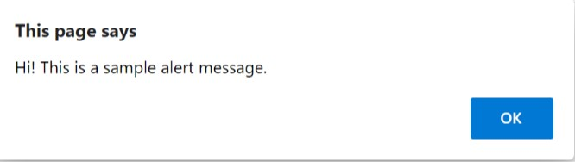

**Task 6**

**Write a script to use prompt and confirm function**

**HTML and JavaScript**

<!DOCTYPE html>

<html>

<head>

<title>Prompt and Confirm</title>

</head>

<body>

<script>

name = prompt("What's your name?")

alert("Your name is " +name)

</script>

<script>

x = confirm("Do you want to continue?");

if (x == true)

{

alert("You have clicked on Ok Button.");

}

else

{

alert("You have clicked on Cancel Button.");

}

</script>

</body>

</html>

**Output:**

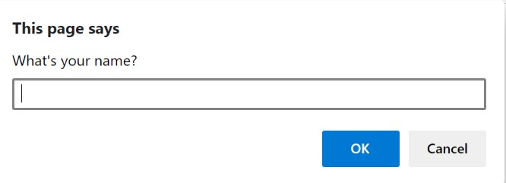

**Task 7**

**Write a script to demonstrate creation and use of an array**

**HTML and JavaScript**

<!DOCTYPE html>

<html>

<head>

<title>Array</title>

</head>

<body>

<h1>Creation and use of an array</h1>

<h4><script>

var arr = [1,2,3,4,5,6,7]

document.write("Array = ", arr, "<br>")

document.write("second element: ", arr[1], "<br>")

document.write("Last element: ", arr[6], "<br>")

</script></h4>

</body>

</html>

**Output:**

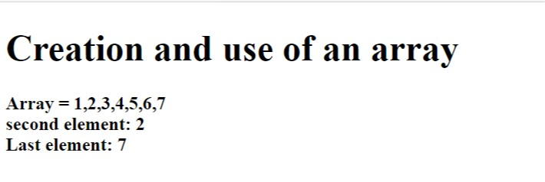

**Task 8**

**Write a script that uses a user defined function**

**HTML**

<!DOCTYPE html>

<html>

<head>

<title>User defined functions</title>

<script src="js/8. function.js" type="text/javascript"></script>

</head>

<body>

<h1>User defined functions</h1>

<h3><script>

myfunction() //function with no argument and no return type

a = square() //function with no argument but return type

document.write("Square of 5 is ", a, "<br>")

square1(6) //function with argument but no return type

var a = square2(7) //function with argument and return type

document.write("Square of 7 is ", a, "<br>")

</script></h3>

</body>

</html>

**JavaScript**

function myfunction(){

document.write("This is a simple user defined function. <br>")

}

function square(){

var n = 5

return n*n

}

function square1(n){

document.write("Square of ", n, " is ", n*n, "<br>")

}

function square2(n){

return n*n

}

Output:

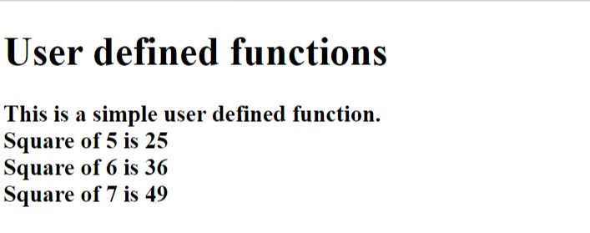

**Task 9**

**Write a script that uses any of the object of BOM**

**HTML and JavaScript**

<!DOCTYPE html>

<html>

<head>

<title>Screen | BOM</title>

</head>

<body>

<h1>Use of a BOM object : Screen</h1>

<p id="demo"></p>

<script>

document.getElementById("demo").innerHTML =

"Screen Resolution: " + screen.width + "*" + screen.height;

</script>

</body>

</html>

**Output:**

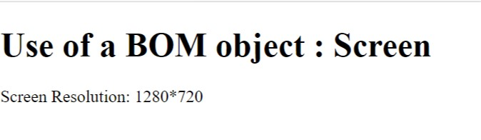

**Task 10**

**Write a script that uses any of the object of DOM**

**HTML and JavaScript**

<!DOCTYPE html>

<html>

<head>

<title>DOM object</title>

</head>

<body>

<h1>Use of a DOM object: write() method</h1>

<h3 id="demo"></h3>

<script>

text = "Hello World!"

document.write(text, "<br>")

document.write(Date())

</script>

</body>

</html>

**Output:**

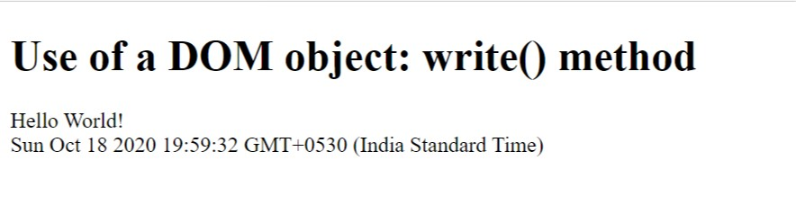

**Task 11**

**Write a script to access any of the form object element**

**HTML and JavaScript**

<!DOCTYPE html>

<html>

<head>

<title>

Form Object Elements

</title>

</head>

<body>

<h1>A script to access any of the form object element</h1>

<br>

<form id="myform" action="#">

Name: <input type="text"> <br>

Course: <input type="text"> <br>

Semester: <input type="number"> <br>

<input type="button" name="submit" value="Show" onclick="value_show()">

</form>

<script type="text/javascript">

function value_show(){

var x = document.getElementById("myform");

var text = "";

for (i = 0; i < x.length-1;i++) {

text += x.elements[i].value + "<br>";

}

document.getElementById("demo").innerHTML = text;

}

</script>

<p id="demo"></p>

</body>

</html>

**Output:**

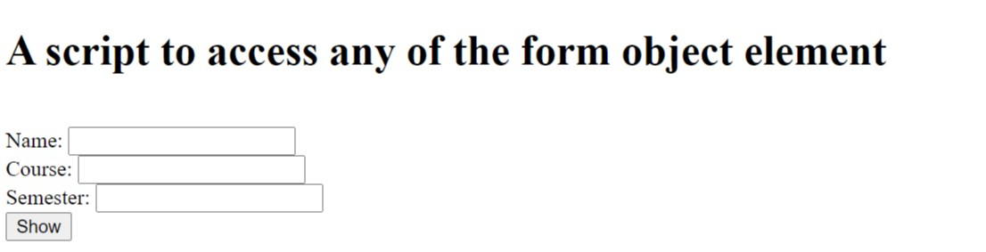

**Task 12**

**Write a script using all of the events**

**HTML and JavaScript**

<!DOCTYPE html>

<html>

<head>

<title>Events in JS</title>

</head>

<body onload="function3()">

<h2>Events in JS</h2>

<h3>Use of onload, onmouseover, onmouseout, onblur and onsubmit</h3>

<h3 onmouseover="style.color='red'" onmouseout="style.color='black'">

This line changes its coler on mouseover</h3>

<form onsubmit="function1()" id="form1" action="https://bing.com">

Name: <input type="text" id="name" onblur="function2()">

<input type="submit">

</form>

<script>

function function1(){

name = document.getElementById("form1").name.value

alert("Hello "+ name + "\nYou will be redirected to bing.")

}

function function2(){

x = document.getElementById("name")

x.value = x.value.toUpperCase()

}

function function3(){

alert("Page is loaded!")

}

</script>

</body>

</html>

**Output:**

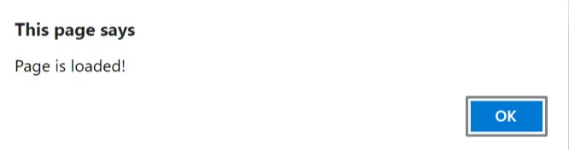

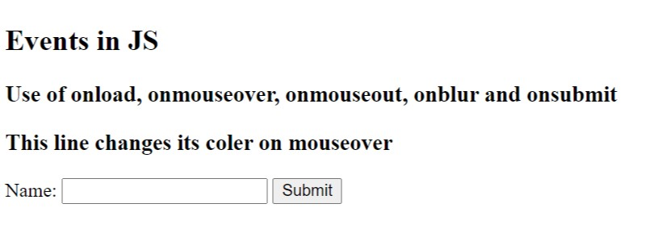

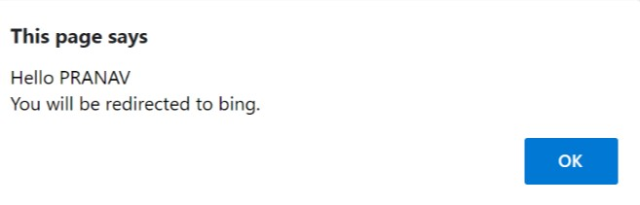

**Task 13**

**Write a script to deal with cookies**

<!DOCTYPE html>

<html>

    <head>

        <title>Cookies</title>

    </head>

    <body>

        <h2>Script to deal with Cookies</h2>

        <button onclick="addcookies()">Add Cookies</button>

        <button onclick="display()">Display Cookies</button>

        <button onclick="deletecookies()">Delete Cookies</button>

        <script>

            var x = document.cookie

            function addcookies(){

                x = "username=crypticani; expires=Thu, 18 Dec 2013 12:00:00 UTC";

                alert("Cookies added")

            }

            function deletecookies(){

                x = "username=; expires=Thu, 01 Jan 1970 00:00:00 UTC;";

                alert("cookies deleted")

            }

            function display(){

                alert(x)

            }

        </script>

    </body>

</html>

**Output:**

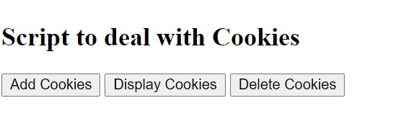

**Task 14**

**Write a script to detect various aspects of Browser**

**HTML**

<!DOCTYPE html>

<html>

<head>

<title>Different aspects of browser</title>

<script src="js/14. browser.js" type="text/javascript"></script>

</head>

<body>

<h2>Detecting various aspects of browser</h2>

<h3>

<script>

cookies()

appname()

appcodename()

engine()

version()

agent()

platform()

language()

online()

java()

</script>

</h3>

</body>

</html>

**JavaScript**

function cookies(){

x = navigator.cookieEnabled

document.write("Cookies enabled: ", x, "<br>")

}

function appname(){

y = navigator.appName

document.write("Application name: ", y, "<br>")

}

function appcodename(){

y = navigator.appCodeName

document.write("Application code name: ", y, "<br>")

}

function engine(){

y = navigator.product

document.write("Browser engine: ", y, "<br>")

}

function version(){

y = navigator.appVersion

document.write("Browser version: ", y, "<br>")

}

function agent(){

y = navigator.userAgent

document.write("Browser agent: ", y, "<br>")

}

function platform(){

y = navigator.platform

document.write("Browser platform: ", y, "<br>")

}

function language(){

y = navigator.language

document.write("Browser language: ", y, "<br>")

}

function online(){

y = navigator.onLine

document.write("Is browser online? : ", y, "<br>")

}

function java(){

y = navigator.javaEnabled()

document.write("Is java enabled? : ", y, "<br>")

}

**Output:**

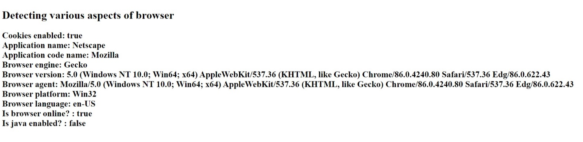

**Task 15**

**Write a script that uses Time events**

**HTML and JavaScript**

<!DOCTYPE html>

<html>

<head>

<title>Timing events</title>

</head>

<body>

<h2>Timing events</h2>

<h4>Click on the below button to recieve an alert after 3 seconds</h4>

<button onclick="myfun = setTimeout(myFunction, 3000)">click me</button>

<button onclick="clearTimeout(myfun)">Stop it</button>

<br><br>

<h4>Current Time: </h4>

<h3 id="time"></h3>

<script>

function myFunction() {

alert('Hello!\nYou recieved this alert after 3 seconds.')

}

</script>

<script>

myfun1 = setInterval(myTimer, 1000)

function myTimer() {

var d = new Date();

document.getElementById("time").innerHTML = d.toLocaleTimeString();

}

</script>

</body>

</html>

**Output:**

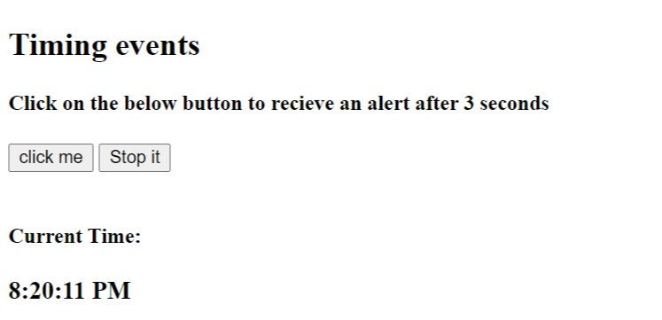

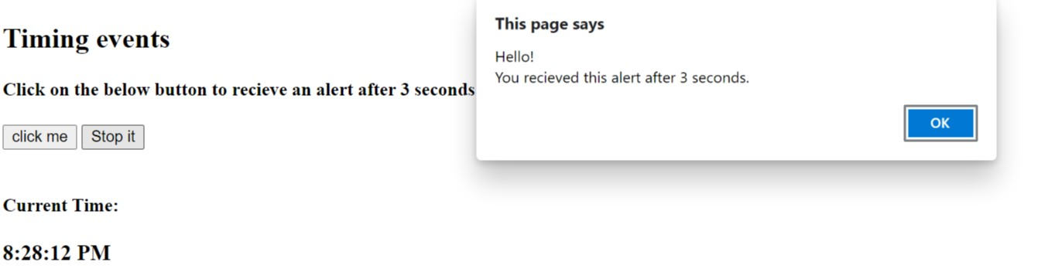

**Task 16**

**Create a Webpage based calculator**

<!DOCTYPE html>

<html lang="en">

<head>

<meta charset="UTF-8">

<meta name="viewport" content="width=device-width, initial-scale=1.0">

<title>Calculator</title>

<link rel="stylesheet" href="style.css">

</head>

<body>

<div class="container">

<h1>Calculator</h1>

<div class="calculator">

<input type="text" name="" id="screen">

<table>

<tr>

<td><input class = 'button' type="button" value="("></td>

<td><input class = 'button' type="button" value=")"></td>

<td><input class = 'button' type="button" value="C"></td>

<td><input class = 'button' type="button" value="/"></td>

</tr>

<tr>

<td><input class = 'button' type="button" value="7"></td>

<td><input class = 'button' type="button" value="8"></td>

<td><input class = 'button' type="button" value="9"></td>

<td><input class = 'button' type="button" value="X"></td>

</tr>

<tr>

<td><input class = 'button' type="button" value="4"></td>

<td><input class = 'button' type="button" value="5"></td>

<td><input class = 'button' type="button" value="6"></td>

<td><input class = 'button' type="button" value="+"></td>

</tr>

<tr>

<td><input class = 'button' type="button" value="1"></td>

<td><input class = 'button' type="button" value="2"></td>

<td><input class = 'button' type="button" value="3"></td>

<td><input class = 'button' type="button" value="-"></td>

</tr>

<tr>

<td><input class = 'button' type="button" value="00"></td>

<td><input class = 'button' type="button" value="0"></td>

<td><input class = 'button' type="button" value="."></td>

<td><input class = 'button' type="button" value="="></td>

</tr>

</table>

</div>

</div>

<script src="script.js"></script>

</body>

</html>

**Css**

.container {

text-align: center;

}

.calculator {

display: inline-block;

padding: 10px;

border: 4px solid #d612ff;

border-radius: 10px;

background: #f7ffc8;

padding-bottom: 0px;

}

table {

margin: auto;

}

td {

padding: 1px 4px;

}

#screen {

height: 28px;

width: 180px;

border-radius: 10px;

outline: none;

margin-bottom: 10px;

padding-left: 6px;

}

.button {

height: 40px;

width: 40px;

border-radius: 10px;

font-size: 18px;

margin-bottom: 10px;

outline: none;

}

.button:hover {

background-color: black;

opacity: 85%;

color: white;

border: solid gold;

cursor: pointer;

}

**JavaScript**

let screen = document.getElementById("screen");

let buttons = document.getElementsByClassName("button");

let content = '';

for (const button of buttons) {

button.addEventListener('click', () => {

let curr = button.value;

if (curr == 'X') {

content += '*';

}

else if (curr == 'C') {

content = '';

}

else if (curr == '=') {

try {

let res = eval(content);

content = res;

} catch (e) {

content = '';

}

}

else {

content += curr;

}

screen.value = content;

});

}

**Output:**

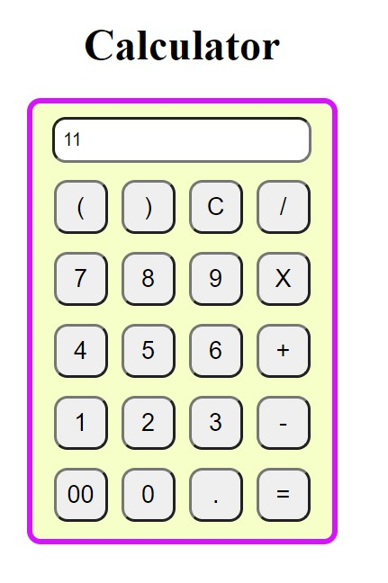

PHP

1. Write a PHP script to get the PHP version and configuration information

**Code:**

<?php

phpinfo();

?>

**Output :-**

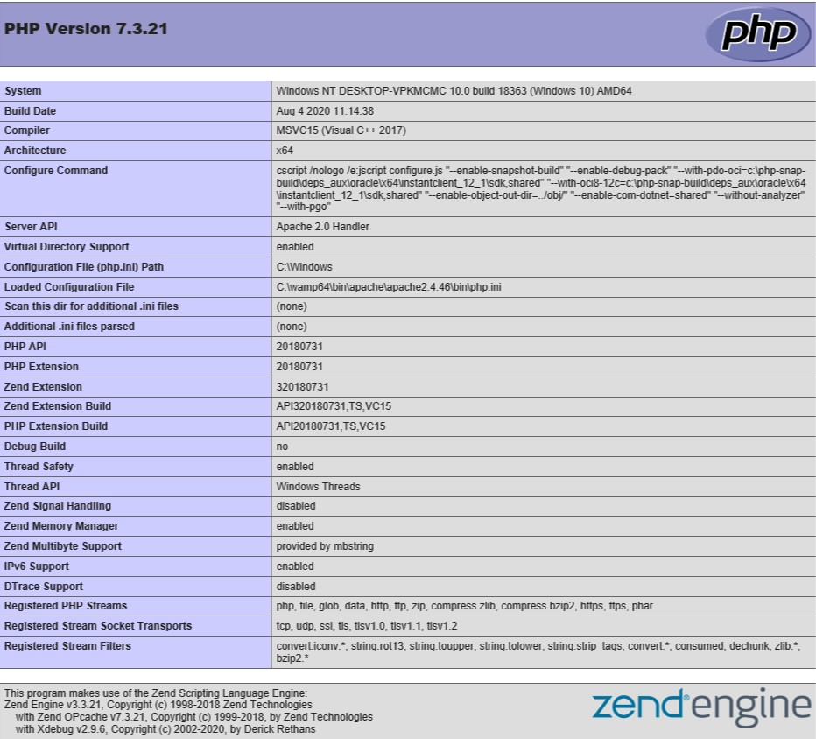

Configuration

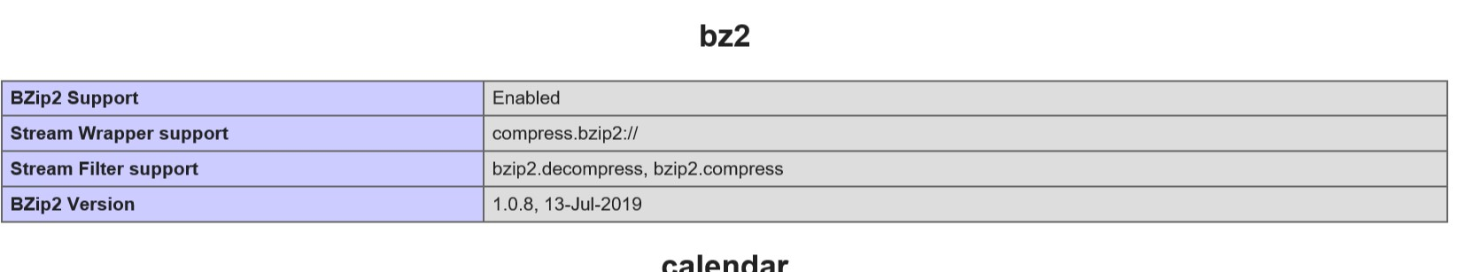



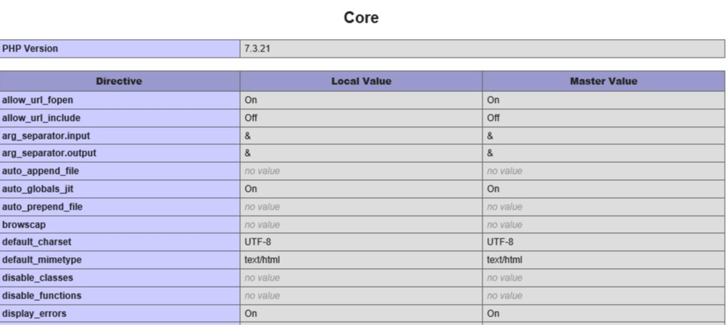

1. Write a PHP script to display any multi-line string

**Code:**

<?php

echo "<h2>A php script</h2> to display multiline string<br>

Hello world!";

?>

**Output:**

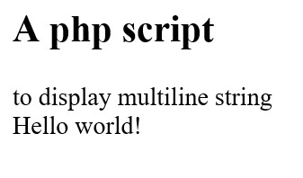

1. Write a PHP script to place a variable to a title and as

hyperlink of the Web page

**Code:**

<!DOCTYPE html>

<html lang="en">

<head>

<meta charset="UTF-8">

<title>

<?php

$var = 'Pranav';

echo $var;

?>

</title>

</head>

<body>

<h3>A PHP script to place a variable to a title and as hyperlink

of the Web page</h3>

<a href ="http://www.bing.com">

<?php

$str= 'Bing Link';

echo $str;

?>

</a>

</body>

</html>

**Output:**

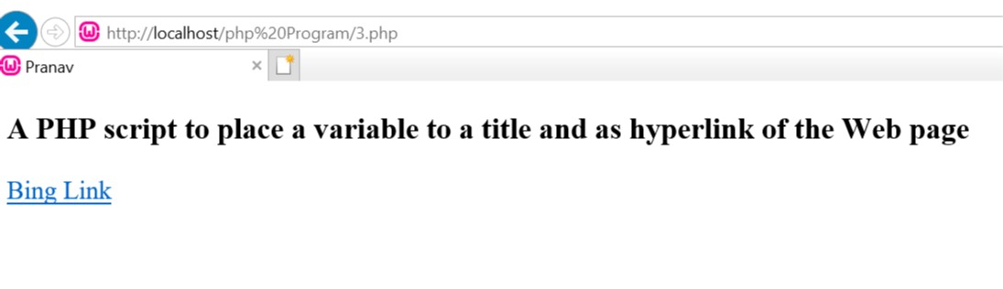

1. Create a simple HTML form and accept the user name and display the name through PHP echo statement

**Code:-**

<html>

<head>

<title>Username</title>

</head>

<body>

<form name="action="4username.php" method="post">

Username:

<input type = "textbox" name="username" placeholder="enter

your username"><br>

<input type="submit" value= "submit"/>

</form>

</body>

</html>

<?php

$username =$_POST['username'];

echo "Your name is :".$username;

echo "<br/>";

?>

**Output:**

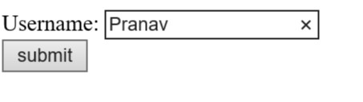

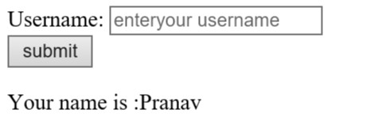

1. Write a PHP script to get IP address of a client

**Code:**

<html>

<head>

<title>IP Address</title>

</head>

<body>

<h2>A PHP script to get IP address of a client</h2>

<?php

$ip = $_SERVER['REMOTE_ADDR'];

echo "Your IP Address = $ip";

?>

</body>

</html>

**Output:-**

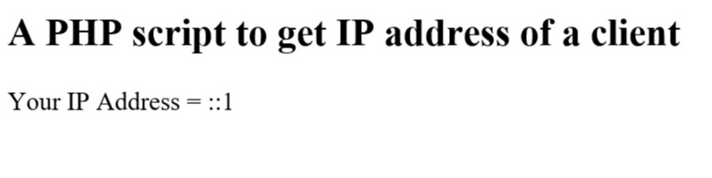

1. Write a PHP script for Browser detection

**Code:**

<h2>Your Browser info: </h2>

<?php

Echo $_SERVER['HTTP_USER_AGENT'];

$browser = getbrowser();

Print_r($browser);

?>

**Output:**



1. Write a PHP script to get the current filename

**Code:**

<?php

echo " <h2>Name of this file is: </h2>";

Echo $_SERVER['PHP_SELF'];

?>

**Output:**

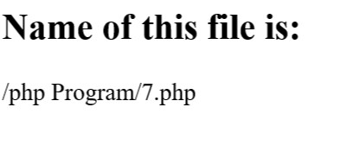

1. Create a PHP script using a for loop to add up all the integers between 0 and 30 and display the total

**Code:**

<?php

$result = 0;

for($i=1; $i<=30; $i++)

{

$result +=$i;

}

echo "The sum of the numbers from 0 to 30 is $result";

?>

**Output:**

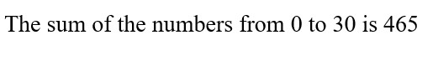

1. Create a function to calculate the factorial of a number (non-negative integer). The function accept the number as a argument.

**Code:**

<?php

function factorial($n)

{

if ($n == 0) {

return 1;

} else {

return $n * factorial($n - 1);

}

}

echo "factorial of 8 is: ";

print_r(factorial(8));

?>

**Output:**

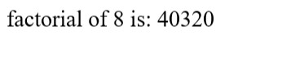

1. Write a function to check a number is prime or not

**Code:**

<h2>Check a number if it is Prime or NOT</h2>

<form method="post">

Enter a Number: <input type="number" name="input"><br><br>

<input type="submit" value="Submit">

</form>

<?php

function prime($number){

if ($number == 1)

return 0;

for ($i = 2; $i <= $number/2; $i++){

if ($number % $i == 0)

return 0;

}

return 1;

}

if($_POST) {

$number = $_POST['input'];

$flag = prime($number);

if ($flag == 1)

echo "Prime";

else

echo "Not Prime";

}

?>

**Output:**

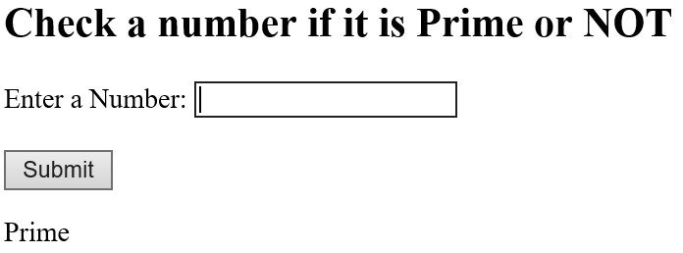

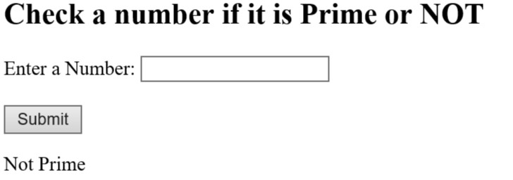

1. Write a function to sort an array

**Code:**

<h2>A function to sort an array</h2>

<h4>Unsorted array: 45, 34, 56, 89, 22, 72</h4>

<?php

function array_sort($a)

{

for($x=0;$x< count($a);++$x)

{

$min = $x;

for($y=$x+1;$y< count($a);++$y)

{

if($a[$y] < $a[$min] )

{

$temp = $a[$min];

$a[$min] = $a[$y];

$a[$y] = $temp;

}

}

}

return $a;

}

$a = array(48, 39, 59, 91, 26, 82);

print_r(array_sort($a));

?>

**Output:**

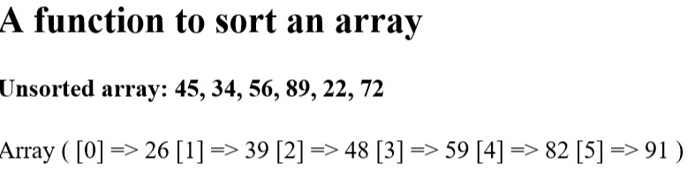

1. Write a PHP function that checks if a string is all lower case

**Code:**

<h3>A PHP function that checks if a string is all lower case</h3>

<form method="post">

Enter the String: <input type="text" name="input"><br><br>

<input type="submit" value="Submit">

</form>

<?php

if($_POST) {

$string = $_POST['input'];

if (ctype_lower($string)) {

echo "Yes, the string is all lowercase";

} else {

echo "No, the string is NOT all lowercase";

}

}

?>

**Output:**

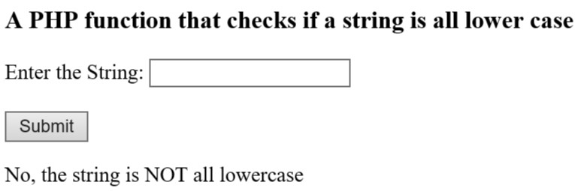

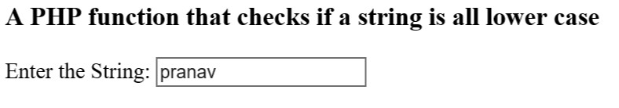

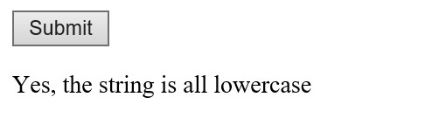

1. Write a PHP function that checks whether a passed string is palindrome or not

**Code:**

<h3>Check the string is Palindrome or not.</h3>

<form method="post">

Enter a String: <input type="text" name="input"><br><br>

<input type="submit" value="Submit">

</form>

<?php

function Palindrome($string){

if (strrev($string) == $string){

return 1;

}

else{

return 0;

}

}

if($_POST) {

$original = $_POST['input'];

if (Palindrome($original)) {

echo "Palindrome";

} else {

echo "Not a Palindrome";

}

}

?>

**Output:**

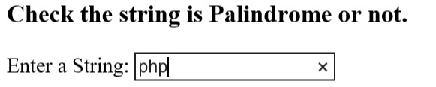

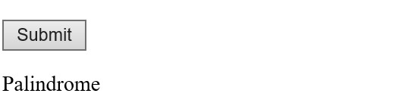

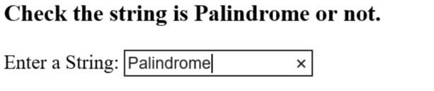

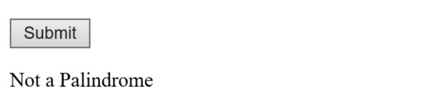

1. Write a PHP script to deal with cookies

**Code:**

<!DOCTYPE html>

<?php

$cookie_name = "user";

$cookie_value = "This is the Task on PHP Cookies";

setcookie($cookie_name, $cookie_value, time() + (86400 * 30),

"/"); // 86400 = 1

day

?>

<html>

<body>

<?php

if(!isset($_COOKIE[$cookie_name])) {

echo "Cookie named '" . $cookie_name . "' is not set!";

} else {

echo "Cookie '" . $cookie_name . "' is set!<br>";

echo "Value is: " . $_COOKIE[$cookie_name];

}

?>

<p><strong>Note:</strong> You might have to reload the page to see

the value of the cookie.</p>

</body>

</html>

**Output:**

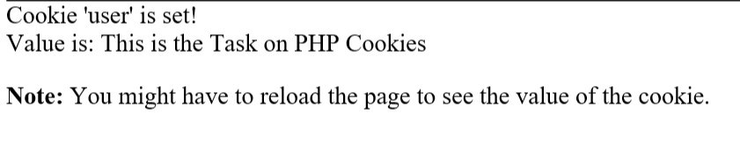

Cookie Deletion

**Code:**

<!DOCTYPE html>

<?php

// set the expiration date to one hour ago

setcookie("user", "", time() - 3600);

?>

<html>

<body>

<?php

echo "Cookie 'user' is deleted.";

?>

</body>

</html>

**Output:**



1. Write a PHP script to handle session

**Code:**

<?php

// Start the session

session_start();

?>

<!DOCTYPE html>

<html>

<body>

<?php

// Set session variables

$_SESSION["UserName"] = "Computer Science Department";

$_SESSION["Subject"] = "Web Development";

echo "Session variables are set.";

?>

</body>

</html>

**Output:**



**MySql**

1. **Use MySQL console to use database**

**Query:**

use pranav;

**Output:**

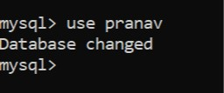

1. **Create a database in MySQL**

**Query:**

create database pranav;

**Output:**

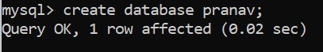

1. Create a table in selected database

**Query:**

create table student (Roll int(7) NOT NULL, Name varchar(20), Marks int(2));

**Output:**

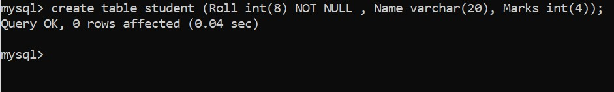

1. **Insert new records in MySQL table**

**Query:**

insert into student values(1824005, "Amit", 8);

**Output:**



1. Retrieve records from the database

**Query:**

select * from student;

**Output:**

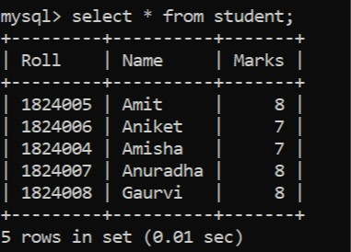

1. Update the records in a table

**Query:**

UPDATE student SET Marks = 9 WHERE Name = 'Amit';

**Output:**

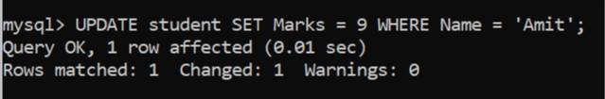

1. Delete a specific record in a table

**Query:**

DELETE FROM student WHERE Name = 'Amisha';

**Output:**

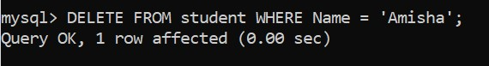

1. Delete the table from the database

**Query:**

DROP TABLE student;

**Output:**

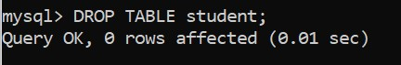

1. Delete the database

**Query:**

DROP DATABASE pranav;

**Output:**



1. Write a PHP script to establish a connection to the database and retrieve the data

|  |  |  |  |
| --- | --- | --- | --- |
| **Code:** |  |  |  |
|  |  |  |  |

<?php

$mysql = new mysqli('localhost', 'myuser', 'password', 'test');

if ($mysql->connect_error) {

die('Connect Error (' . $mysql->connect_errno . ') '

. $mysql->connect_error);

}

echo 'Success... ' . $mysql->host_info . "\n";

$query = mysqli_query($mysql,"SELECT * FROM student");

if (mysqli_num_rows($query) > 0){

?>

<br><br>

<table>

<tr>

<td>Roll No</td>

<td>Name</td>

<td>Marks</td>

</tr>

<?php

$i=0;

while($row = mysqli_fetch_array($query)) {

?>

<tr>

<td><?php echo $row["Roll"]; ?></td>

<td><?php echo $row["Name"]; ?></td>

<td><?php echo $row["Marks"]; ?></td>

</tr>

<?php

$i++;

}

?>

</table>

<?php

}

else{

echo "No result found";

}

$mysql->close();

?>

**Output:**

